Laboratoriya ishi №10
Mavzu: CSS transition va animatsiya elementlarini yaratish
Fan: Web ilovalar
1. Ishdan maqsad
CSS yordamida veb-sahifalardagi elementlarga silliq o‘tish (transition) va harakatli effektlar (animation) qo‘shish texnikasini o‘rganish.

2. Nazariy qism

2.1. CSS Transition
Transition – bu biror elementning uslubi o‘zgarganda o‘tish jarayonini silliq amalga oshirish imkonini beradi.
Masalan: tugma ustiga sichqoncha olib borilganda rangi asta-sekin o‘zgaradi.
Asosiy xossalar:
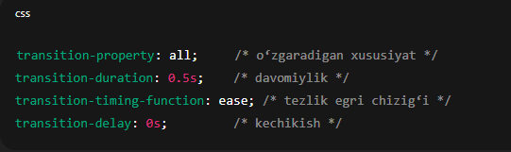
Yoki qisqa yozilishi:
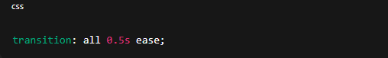

2.2. CSS Animation
Animation esa elementning xatti-harakatini vaqt o‘tishi bilan ketma-ket holatlar orqali boshqaradi.
Buning uchun @keyframes qo‘llaniladi.
Asosiy sintaksis:
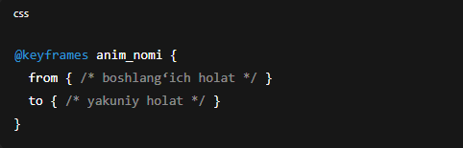
Yoki foizlarda:
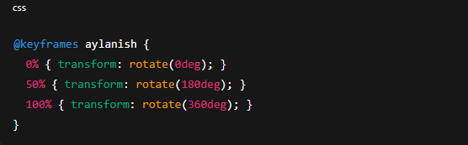Qo‘llash:
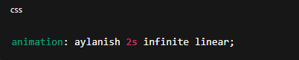

3. Amaliy qism

3.1. HTML fayl (index.html)
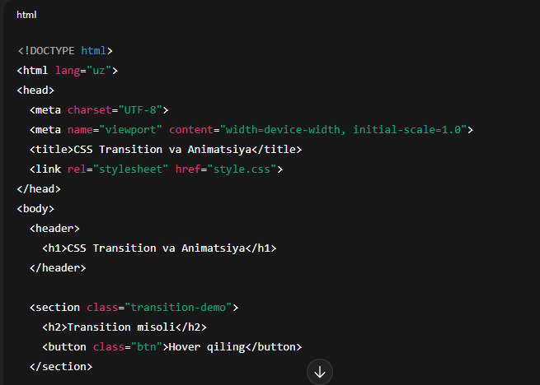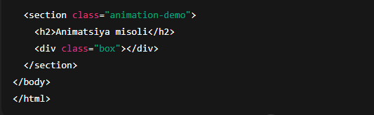

3.2. CSS fayl (style.css)
body {
font-family: Arial, sans-serif;
margin: 0;
padding: 0;
text-align: center;
}

header {
background: #007bff;
color: white;
padding: 15px;
}

/* --- Transition misoli --- */
.btn {
background-color: #28a745;
color: white;
border: none;
padding: 15px 30px;
font-size: 16px;
border-radius: 10px;
cursor: pointer;
transition: background-color 0.5s ease, transform 0.3s;
}

.btn:hover {
background-color: #218838;
transform: scale(1.1);
}

/* --- Animation misoli --- */
.box {
width: 100px;
height: 100px;
background-color: #ff5733;
margin: 40px auto;
border-radius: 10px;
animation: harakat 3s infinite alternate ease-in-out;
}

/* Animatsiya ketma-ketligi */
@keyframes harakat {
0% { transform: translateX(0); background-color: #ff5733; }
50% { transform: translateX(150px); background-color: #ffc300; }
100% { transform: translateX(-150px); background-color: #28a745; }
}

4. Natija
Transition misoli: foydalanuvchi tugma ustiga sichqoncha olib borganda, tugma rangi va o‘lchami silliq tarzda o‘zgaradi.
Animatsiya misoli: rangli kvadrat chapdan o‘ngga harakatlanib, rangi o‘zgaradi.
Natija: foydalanuvchiga vizual jihatdan yoqimli, harakatli interfeys yaratish imkoniyati hosil bo‘ladi.
Topshiriq: Sumka do’konining sayti

<!DOCTYPE html>
<html lang="uz">
<head>
<meta charset="UTF-8">
<title>Brend Sumkalar Do'koni</title>
<style>
body {
font-family: Arial, sans-serif;
background-color: #ffc0cb; /* Pushti fon */
margin: 20px;
}
h1 {
text-align: center;
color: #fff;
text-shadow: 1px 1px 2px #000;
}
.container {
display: flex;
flex-wrap: wrap;
justify-content: center;
gap: 20px;
}
.product {
background-color: #fff;
border: 1px solid #ddd;
border-radius: 8px;
width: 250px;
padding: 10px;
box-shadow: 0 2px 5px rgba(0,0,0,0.1);
}
.product img {
width: 100%;
height: auto;
border-radius: 5px;
}
.product h2 {
font-size: 18px;
margin: 10px 0 5px;
text-align: center;
}
.product p {
font-size: 16px;
color: #555;
text-align: center;
}
</style>
</head>
<body>
<h1>Brend Sumkalar Do'koni</h1>
<div class="container">

<div class="product">
<img src="https://lombard-chasov.ru/images/products/WGhLHVZZblM0aJVNIeBFB6Wf2x3Ol0awkmsytSf4.jpg" alt="Chanel sumkasi">
<h2>Chanel</h2>
<p>Narxi: 250 000 so'm</p>
<p> Qizil, Oq, Qora ranglari bor</p>
</div>
<div class="product">
<img src="https://images.satu.kz/182561790_w640_h640_sumka-gucci-gg.jpg" alt="Gucci sumkasi">
<h2>Gucci</h2>
<p>Narxi: 300 000 so'm</p>
<p> To'q qizil, Oq, Qora ranglari bor</p>
</div>
<div class="product">
<img src="https://images.prom.ua/6582789822_w640_h640_sumka-louis-vuitton.jpg" alt="Louis Vuitton sumkasi">
<h2>Louis Vuitton</h2>
<p>Narxi: 200 000 so'm</p>
<p> Oq, Kulranglari bor</p>
</div>
<div class="product">
<img src="https://cdn1.ozone.ru/s3/multimedia-1-5/c600/7056374333.jpg" alt="Dior sumkasi">
<h2>Dior</h2>
<p>Narxi: 280 000 so'm</p>
<p> Oq va Pushti gulli ranglari bor</p>
</div>
<div class="product">
<img src="https://images.prom.ua/6522454428_w640_h640_zhenskaya-sumka-stil.jpg" alt="Zara sumkasi">
<h2>Zara</h2>
<p>Narxi: 450 000 so'm</p>
<p> Oq, Qora Kulranglari bor</p>
</div>
<div class="product">
<img src="https://images.uzum.uz/cmu93m125kub33f23do0/original.jpg" alt="Hermès sumkasi">
<h2>Hermès</h2>
<p>Narxi: 350 000 so'm</p>
<p> Har xil turdagi ranglari bor</p>
</div>
</div>
</body>
</html>

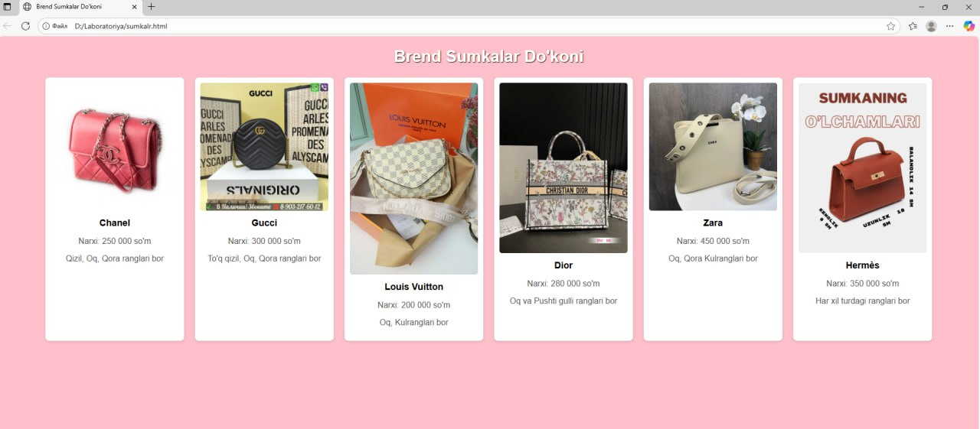

5. Xulosa
Ushbu laboratoriya ishida CSS transition va animation elementlarining ishlash prinsipi amaliy tarzda o‘rganildi.
Bu texnikalar yordamida veb-sahifalarga interaktivlik, dinamika va vizual joziba qo‘shish mumkin.

